Media release 13 November 2019

Tunnel Digitalisation Center builds the bridge from real to digital

Flums, 13. November 2019 – At the end of October, the Tunnel Digitalisation Center was officially opened in the Hagerbach Test Gallery. For the first time, it allows demonstration and simulation in a realistic environment. Around 40 guests from the construction industry, consisting of partners, clients, planners and suppliers from Switzerland, Germany and Austria, accepted the invitation to the demo center of a digital tunnel. The project is a joint initiative of SCAUT, Amberg Engineering Ltd, Siemens Ltd, Elkuch Group Ltd and HBI Haerter Ltd.

The challenge of simplifying complex processes

The Tunnel Digitalisation Center (TDC) offers the unique opportunity to experience the interaction and transformation from real to digital directly in the tunnel. New technologies and innovative concepts can be demonstrated on a scale of 1:1, which leads to a better understanding of complex processes and procedures as well as a high level of cost-efficiency.

Higher added value throughout the entire product life cycle

The focus is on cross-phase and cross-divisional system solutions that span the entire value chain and life cycle of tunnel systems – from planning with BIM and the subsequent structural work and electromechanical equipment to the operating phase and digital maintenance services. In particular, the interaction between different partners will be demonstrated using shared use cases and presented live on site.

Benefit from digitalisation

In addition to reducing complexity, the Tunnel Digitalisation Center focuses on saving time, optimising efficiency and increasing productivity. This goal is achieved with standardised, efficient engineering and a high degree of automation. As a result, tunnels can be put into operation earlier thanks to virtual commissioning, training and simulations. The high level of safety and optimised maintenance also enable the tunnel to be operated sustainably and permanently.

The "Tunnel Digitalisation Center" project was initiated by the Swiss Center of Applied Underground Technologies (SCAUT). The companies Amberg Engineering Ltd with its expertise in infrastructure construction, Siemens Ltd for automation, Elkuch Group Ltd as the expert for door systems and HBI Haerter Ltd for tunnel ventilation simulations were won as industrial partners.

Convince yourself of the added value of digital system solutions and the interaction with the real tunnel environment and visit our Tunnel Digitalisation Center in the Hagerbach Test Gallery.

Quote Michael Rom, Head of Factory Automation at Siemens Schweiz Ltd:
"The Tunnel Digitalisation Center offers us the unique opportunity to show the digital twin in a real tunnel. And not only in terms of pure automation but also in terms of how the individual components interact. In this way, we can check and improve existing models and test future applications or use cases."

Quote Philipp Dohmen, Head of Digitalisation of the Amberg Group Ltd:
"With the Tunnel Digitalisation Center, digitalisation can be experienced through the various performance phases. You can see connections and get a glimpse of tomorrow's possibilities. Data modelling is our part in the value chain and marks the starting point for the digital infrastructure construction of the future."

For further information, please visit our website or contact on behalf of the industry consortium:

https://www.scaut-association.com/en/Our-Projects/Category/Tunnel-Digitalisation-Center/Tunnel-Digitalisation-Center
SCAUT – Swiss Center of Applied Underground Technologies
Klaus Wachter
Managing Director
Phone +41 78 642 83 83
kwachter@scaut-association.com

The Swiss Centre of Applied Underground Technologies (SCAUT) is the world’s leading competency centre for the use of the underground space. It relies on high-end engineering, innovative solutions and most advanced ITC to make a substantial contribution to the creation of underground spaces for the future and to provide relief for metropolises and highly populated urban areas.

The SCAUT consortium working on the "Tunnel Digitalisation Center" project consists of the following industry partners: Amberg Engineering Ltd, Siemens Ltd, Elkuch Group Ltd and HBI Haerter Ltd.

www.scaut-association.com
Images:
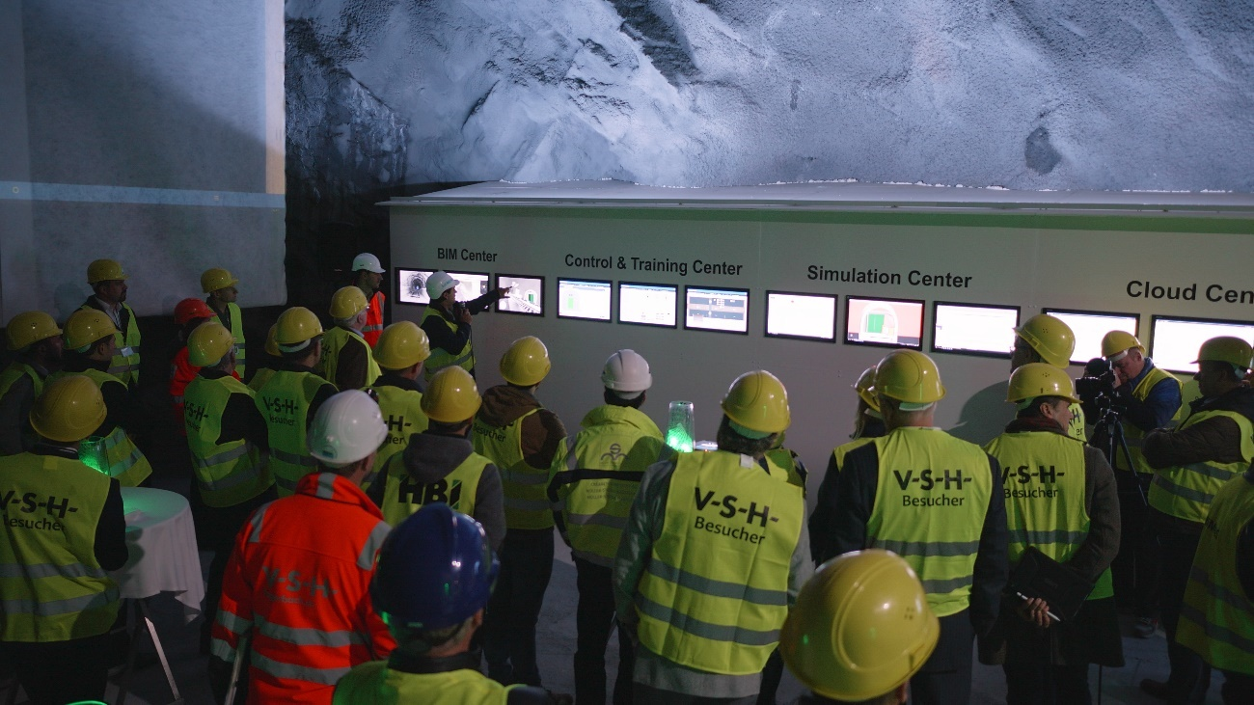
Image 1:
Numerous guests attended the opening of the Tunnel Digitalisation Center in Flums at the end of October.

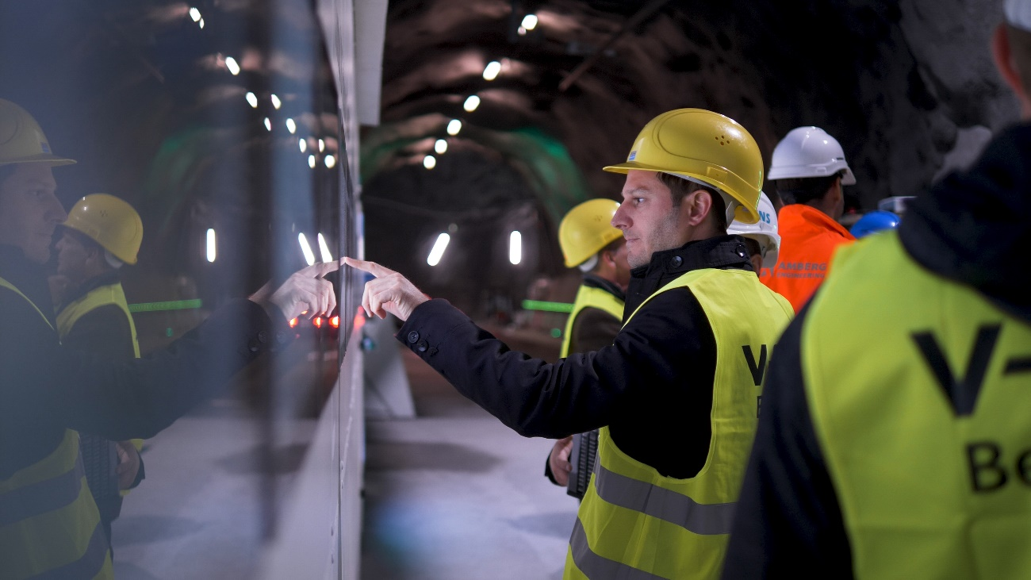

Image 2:
After the presentation of the Digitalisation Centre, the guests could test the demo centre and ask the present experts questions about tunnel digitalisation.

Images: SCAUT – Swiss Center of Applied Underground Technologies

